***PAAREES PERFUMES***

***Christian Diors***

***FOR UNISEX***

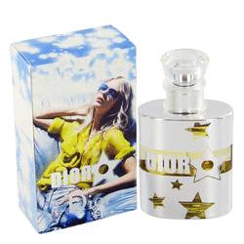

# *Dior Star*

***Description:***

Dior Star by Christian Dior Perfume. Take center stage wearing a captivating women's scent from the fashion and fragrance house founded by Christian Dior. Introduced in 2005, Dior Star puts you in the limelight, bringing the chic cachet of its luxurious French label. This enchanting fruity and floral composition mixes intoxicating, and romantic notes of peony and honeysuckle with citrus elements of Mandarin orange, bergamot and petitgrain, the essence of orange leaf. Feel confident and glamorous with Dior Star in your beauty arsenal.